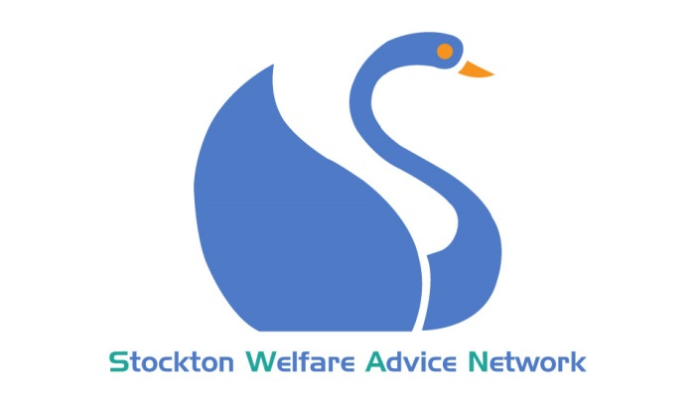

CARERS AND THE CARED FOR
13th September 2017
Jim Cooke Suite, Stockton Library

MARIE KERR- SWAN Project Manager
Introduction and update on SWAN
Carers and advice issues- Sandwich Carers
KAREN SHAW- Commissioning Officer for Carers Service, Stockton Borough Council
Information on the new Carers Hub and resources available to help signpost carers for the help they need
REBECCA GRAY- Stockton Personalisation Team, Stockton Borough Council
Information on Carers Assessments and budgets
ZOE LIDDLE- National Co-production Group
Information on My Voice My Choice, Stockton’s answer to Integrated Personal Commissioning
SUSAN GRIFFITHS- Benefit Adviser, Stockton & District Advice and Information Service
The latest updates on benefits for carers
DISCUSSION
How can we make this information more available for carers?
What further work can be done to bring information to carers

